**REPORT**

**Efficient PCB Design with Tinkercad and EasyEDA: Bridging the Gap Between Virtual Prototyping and Breadboard Hardware Implementation**

Reported by : TEAM PMG

TEAM MEMBERS:

* P.PRUDVI REDDY
* MC.MOKSHITH
* B.GOPAL

**Reported on:** 30/5/2024

Simulation Results

* LED(ON-OFF):

1. Description :

* In this circuit setup, a Slide switch (S1) is employed to control the flow of electricity. When the slide switch is in the "on" position, it completes the circuit. A 1 kΩ resistor (R1) is included in the circuit to limit the current flowing through the system and protect the LED from burning out.
* The heart of the circuit, the Green LED (D3), illuminates when the circuit is closed, completing the electrical pathway. LEDs emit light when current flows through them in the forward direction.
* Finally, a 5V power supply (P2) is connected to provide the necessary voltage for the circuit to operate. When the switch is turned on, current flows from the positive terminal of the power supply, through the resistor, through the LED, and back to the negative terminal of the power supply, completing the circuit. This flow of current causes the LED to emit light, indicating that the circuit is active.
* In summary, by sliding the switch to the "on" position, you allow current to flow through the circuit, illuminating the LED and turning it "on." Converselysliding the switch to the "off" position interrupts the flow of current, turning the LED "off."

1. OUTPUTS:

Tinkercad circuit:

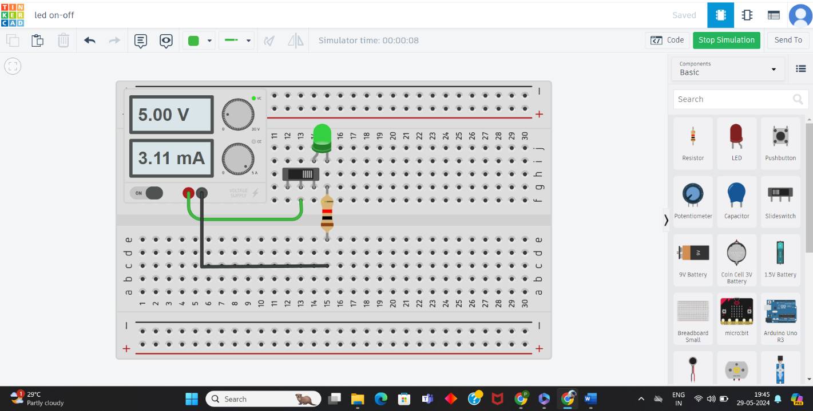

Schematic view:

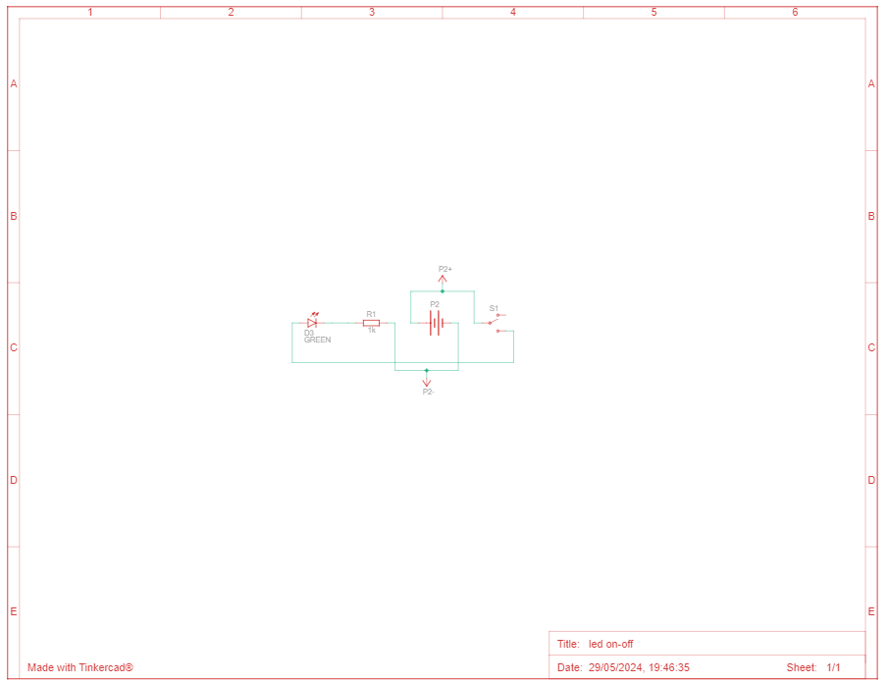

Components:



1. Transient Response:

* The LED circuit's transient response reveals its dynamic nature during switching. When activated, the LED gradually brightens until fully lit, while deactivation prompts a gradual dimming until off. These transitions happen rapidly, within milliseconds, showcasing the LED's quick adaptation to circuit changes. Understanding this response sheds light on the circuit's dynamic behavior, emphasizing its responsiveness to switching actions.

1. PCB Designing in EasyEda:

Circuit:

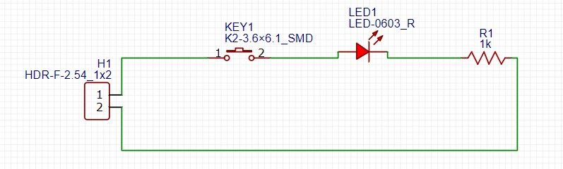

2D VIEW:

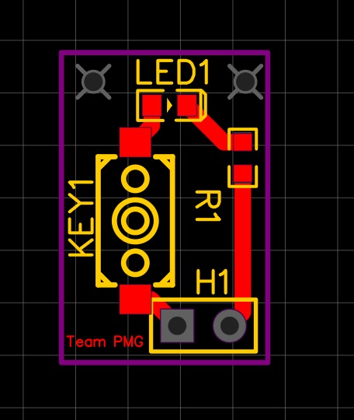

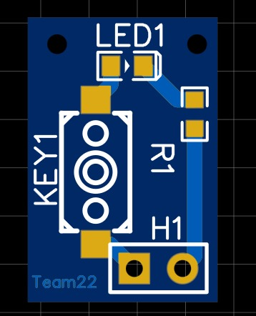

3D VIEW:

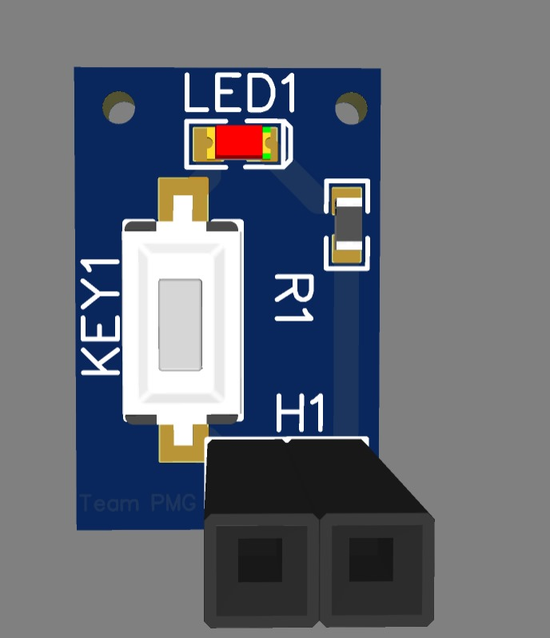

* HALF ADDER:

1. Description :

* The half adder circuit is a fundamental digital circuit designed to perform the binary addition of two single-bit inputs, producing two outputs: the sum and the carry. In this Tinkercad implementation, the components used include a Red LED (D1) to indicate the carry output, a Green LED (D2) to indicate the sum output, two 1 kΩ resistors (R1, R2) to limit the current and protect the LEDs, multiple 5V power supplies (P4, P5, P6) to provide the necessary voltage, a 74HC08 Quad AND Gate (U1), and a 74HC86 Quad XOR Gate (U3). The two inputs are connected to both the AND gate and the XOR gate. The XOR gate calculates the sum of the inputs, lighting the Green LED when the inputs are different. The AND gate calculates the carry output, lighting the Red LED when both inputs are high. Resistors ensure that the LEDs are not exposed to excessive current. This setup effectively demonstrates the basic operation of a half adder, showcasing how logical gates can be used to perform simple binary addition with clear visual indicators for the sum and carry outputs.

1. OUTPUTS:

Tinkercad circuit:

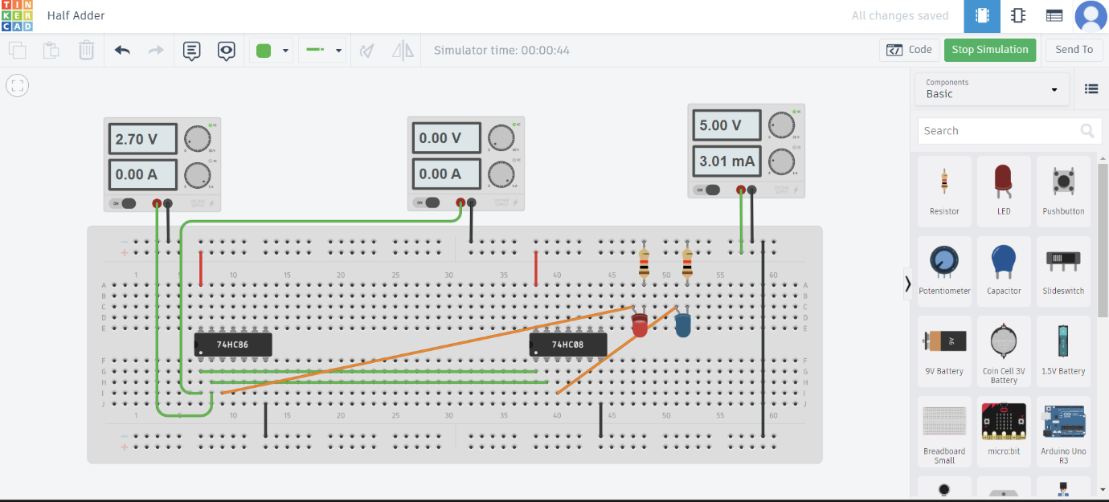

Schematic view:

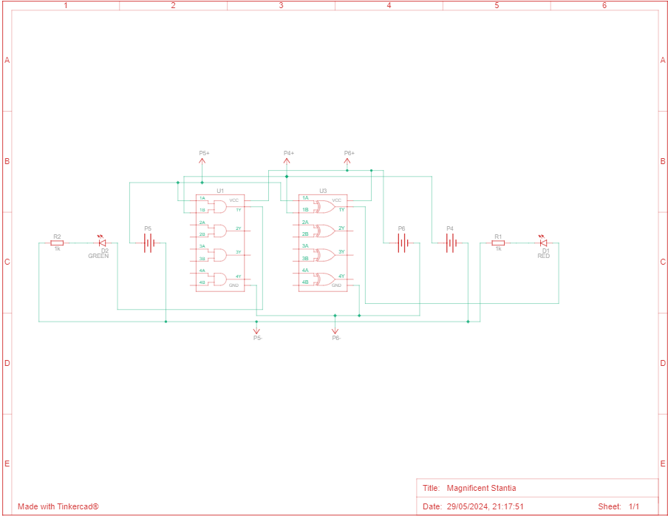

Components:

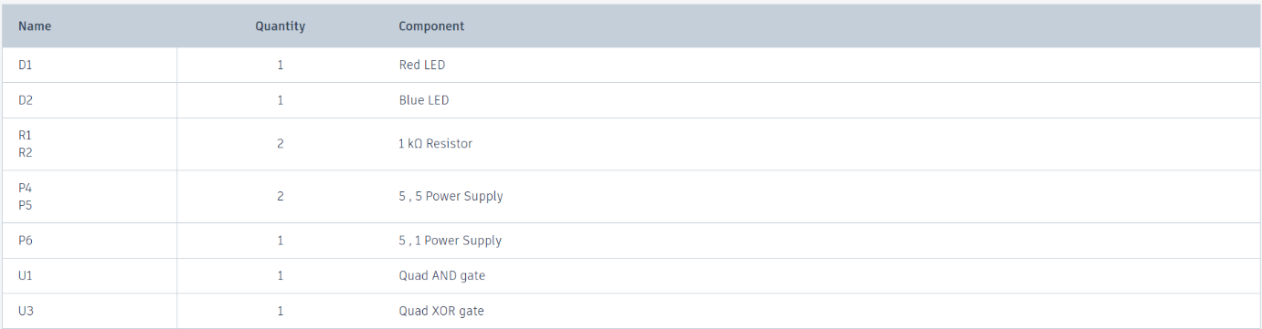

1. Transient Response:

* The transient response of the half adder circuit illustrates the behavior of the sum and carry outputs immediately after a change in the inputs. When the input states (A and B) switch, the signals propagate through the 74HC08 Quad AND Gate and the 74HC86 Quad XOR Gate, causing the outputs to transition. Initially, there may be a brief period of instability as the gates process the change. The sum output, indicated by the Green LED, and the carry output, indicated by the Red LED, adjust quickly to reflect the new input states. The Green LED lights up or turns off based on the XOR gate's output, while the Red LED does the same based on the AND gate's output. These transitions occur rapidly, typically within nanoseconds to microseconds, demonstrating the quick response of the circuit to input changes. This dynamic behavior highlights the efficiency of logical gates in processing and stabilizing new input signals.

1. PCB Designing in EasyEda:

Circuit:

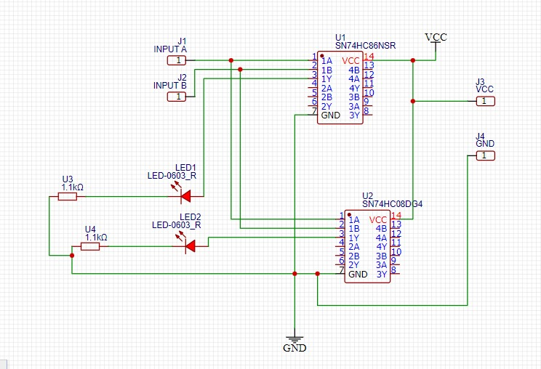

2D VIEW:

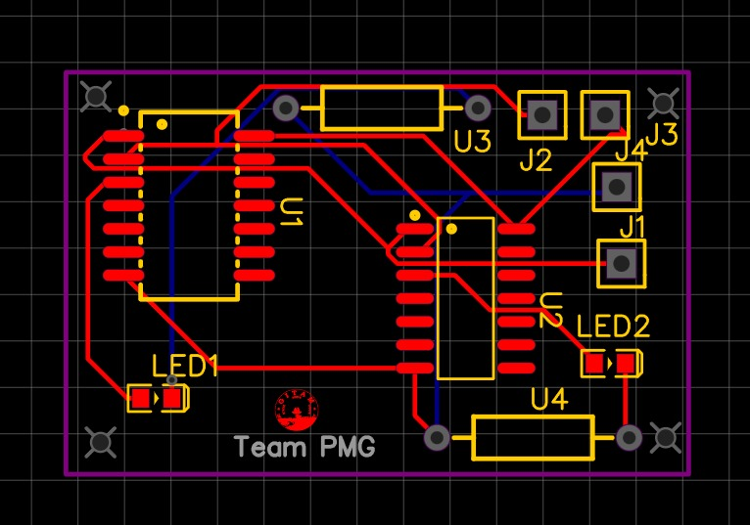

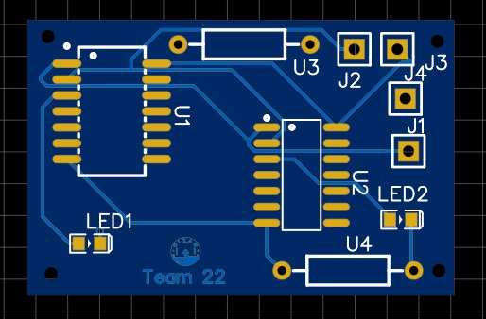

3D VIEW:

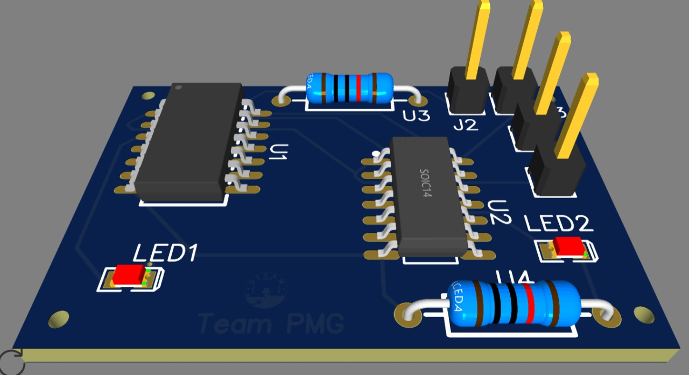

* 555IC:

1. Description :

* In this Tinkercad implementation, a 555 timer IC is configured as an astable multivibrator to generate a continuous square wave output. The circuit is powered by a 6.3V, 5V power supply (P1), which provides the necessary voltage to the components. The 555 timer (U1) uses a combination of resistors and a capacitor to set the timing intervals for the oscillation. Specifically, a 220 Ω resistor (R1) is connected in series with a 6.8 kΩ resistor (R2) and a 16 kΩ resistor (R3). These resistors, along with a 1 µF, 16V polarized capacitor (C2), determine the charge and discharge times of the capacitor, which in turn set the frequency and duty cycle of the output waveform. The output of the 555 timer is connected to a Red LED (D1) through the 220 Ω resistor (R1), which limits the current to prevent damage to the LED. As the 555 timer oscillates, it switches between its high and low states, causing the Red LED to blink on and off, visually demonstrating the timer's oscillatory behavior. This setup effectively illustrates how a 555 timer can be used to create a simple blinking LED circuit, showcasing its applications in generating timing pulses and oscillations.

1. OUTPUTS

Tinkercad circuit:

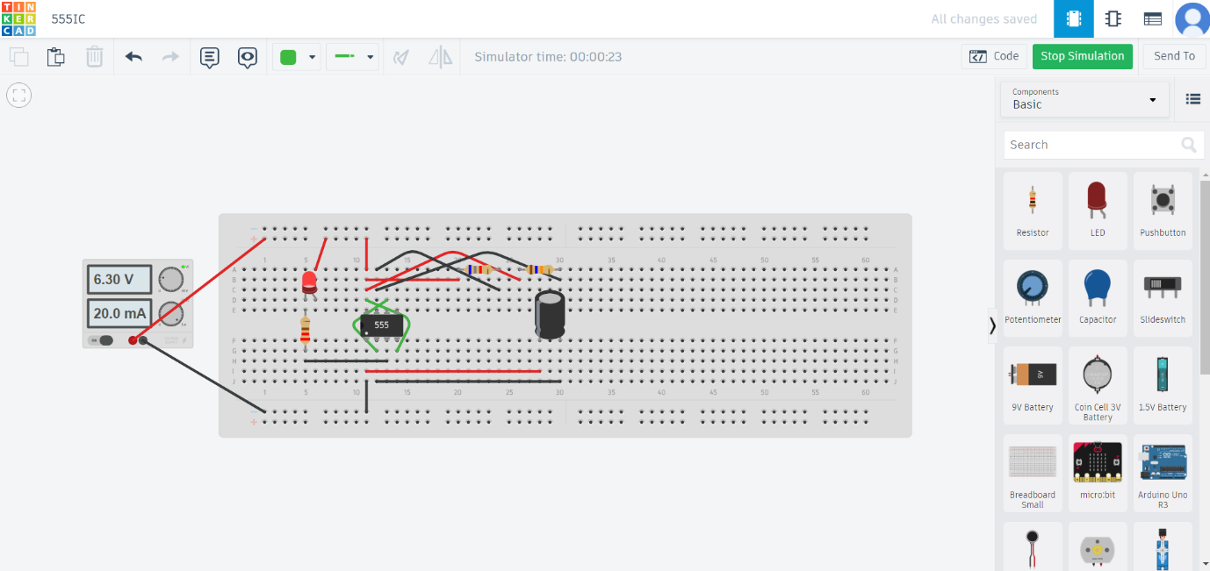

Schematic view:

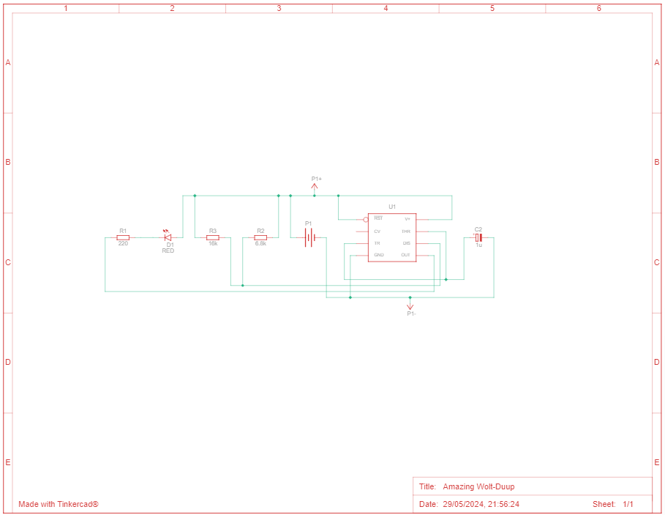

Components:



1. Transient Response:

* The transient response of the 555 timer circuit demonstrates the behavior of the circuit during the transition periods of its oscillation cycle. Upon powering the circuit with the 6.3V, 5V power supply (P1), the 555 timer (U1) begins its oscillation. The 1 µF, 16V polarized capacitor (C2) charges through the 6.8 kΩ (R2) and 16 kΩ (R3) resistors until it reaches a threshold voltage, at which point the 555 timer switches its output from low to high. This causes the Red LED (D1) to turn on. As the capacitor discharges through the same resistors, the voltage drops until it hits a lower threshold, causing the timer to switch the output back to low and the Red LED to turn off. These rapid transitions, occurring within milliseconds, result in a continuous square wave output, with the LED blinking on and off to visually represent the timer's oscillatory behavior.

1. PCD PCB Designing in EasyEda:

Cicuit:

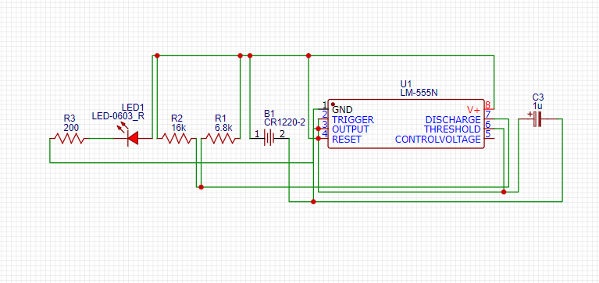

2D VIEW:

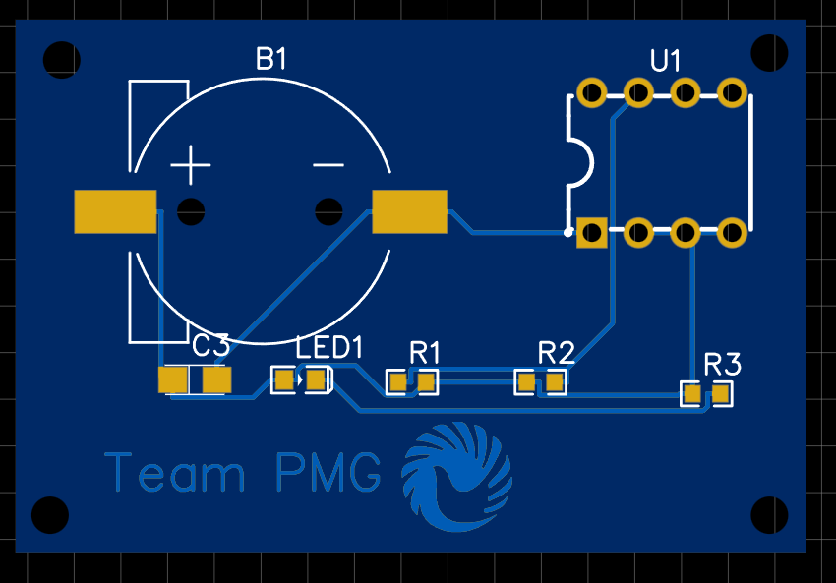

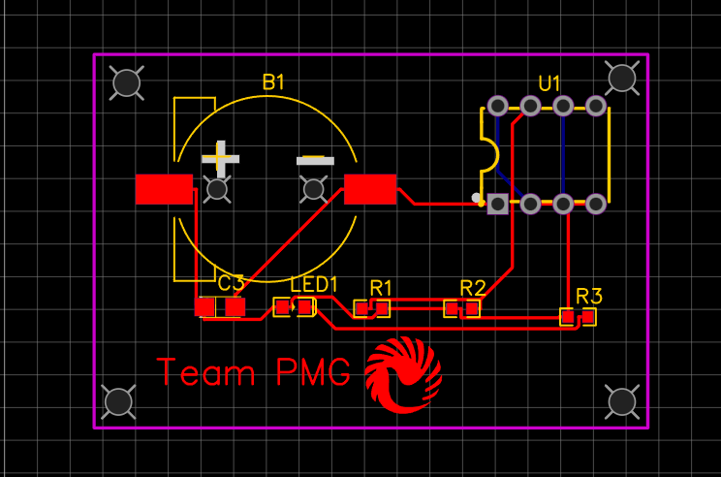

3D VIEW:

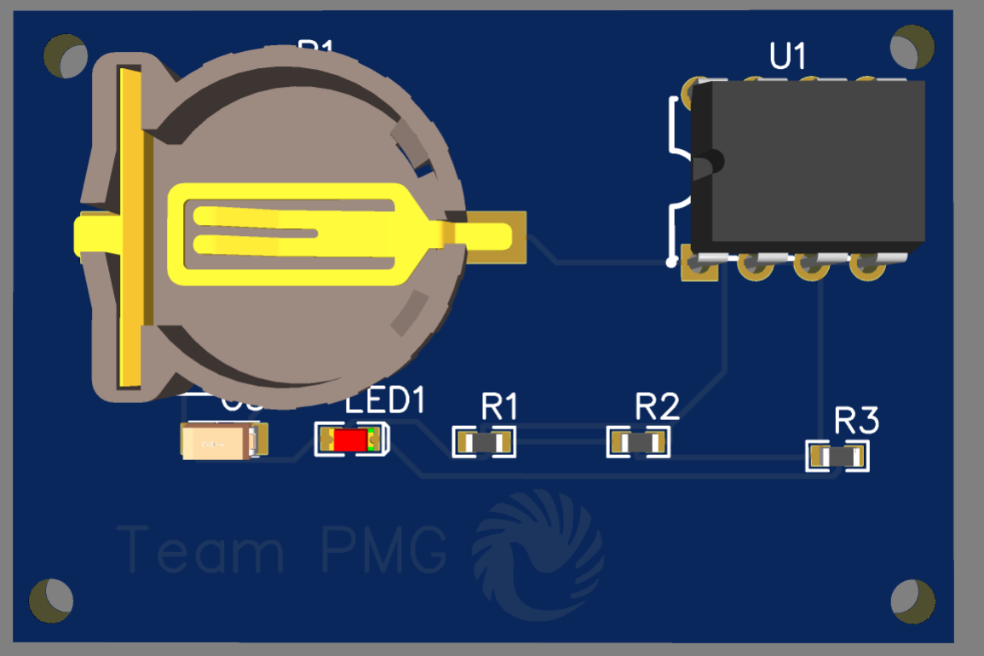

* Task-1:Digital:Gray to Binary:

1. Description :

* In this Tinkercad project, a Gray to Binary code converter is constructed using a Quad XOR gate (U1), a DIP switch SPST x 4 (SW1), four 1 kΩ resistors (R1, R2, R3, R4), and four LEDs (D1 - Blue, D2 - Green, D3 - Red, D4 - Yellow) for output indication, all powered by a 5V supply (P1). The DIP switch allows users to input a 4-bit Gray code, which is processed by the Quad XOR gate to convert it into a 4-bit binary code. The conversion logic works as follows: the most significant bit (MSB) of the binary output is the same as the MSB of the Gray code; each subsequent bit of the binary output is generated by XORing the previous binary bit with the corresponding Gray code bit. The converted binary output is then indicated by the four LEDs, with each LED corresponding to one bit of the binary output. The resistors limit the current through the LEDs to prevent damage. This setup effectively demonstrates the conversion process from Gray code to binary code, with clear visual feedback provided by the LEDs.

1. OUTPUTS:

Tinkercad circuit:

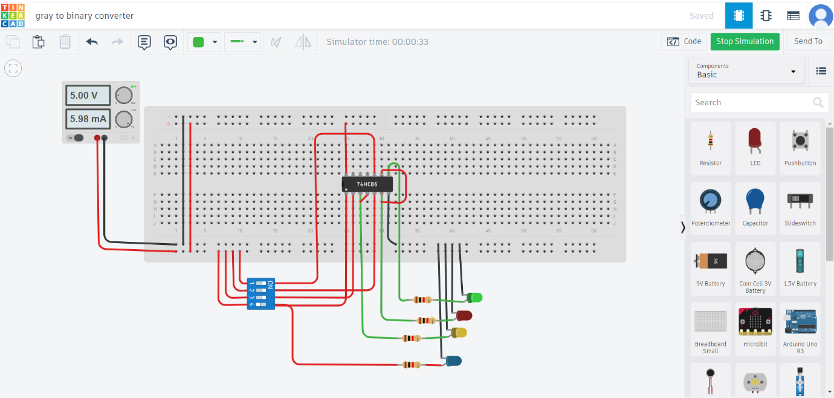

Schematic view: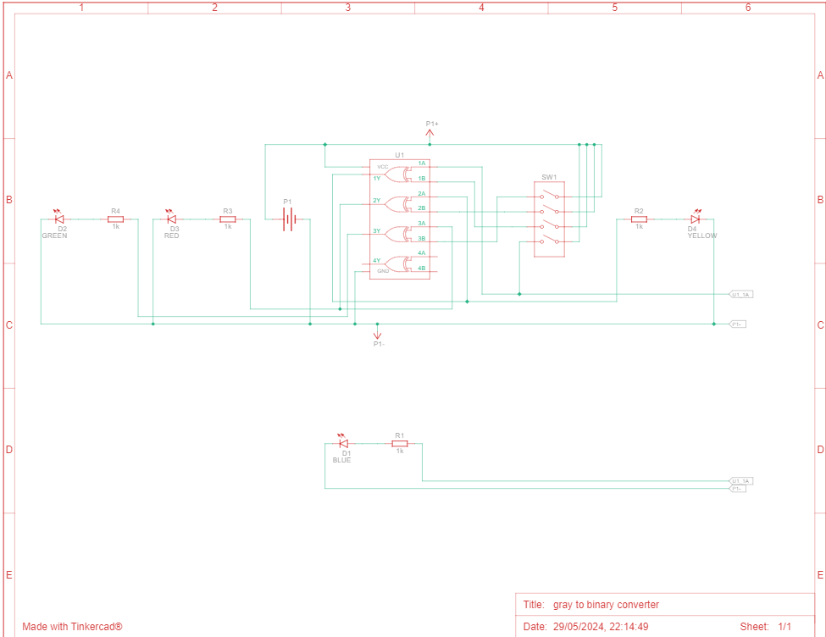

Components:



1. Transient Response:

* The transient response of the Gray to Binary code converter circuit shows how the circuit reacts to changes in the input Gray code provided by the DIP switch (SW1). When a switch is toggled, the input Gray code changes, and this new input is immediately processed by the Quad XOR gate (U1). The XOR gate quickly recalculates the binary output based on the new input. The transition is almost instantaneous, as the new binary code is generated and displayed by the LEDs (D1 - Blue, D2 - Green, D3 - Red, D4 - Yellow). Each LED represents a bit of the binary output, and the corresponding resistors (R1, R2, R3, R4) ensure current is limited to safe levels. This swift change from the old to the new binary output demonstrates the quick response of the circuit to input variations, providing immediate visual feedback through the LEDs.

4.Hardware Implementation: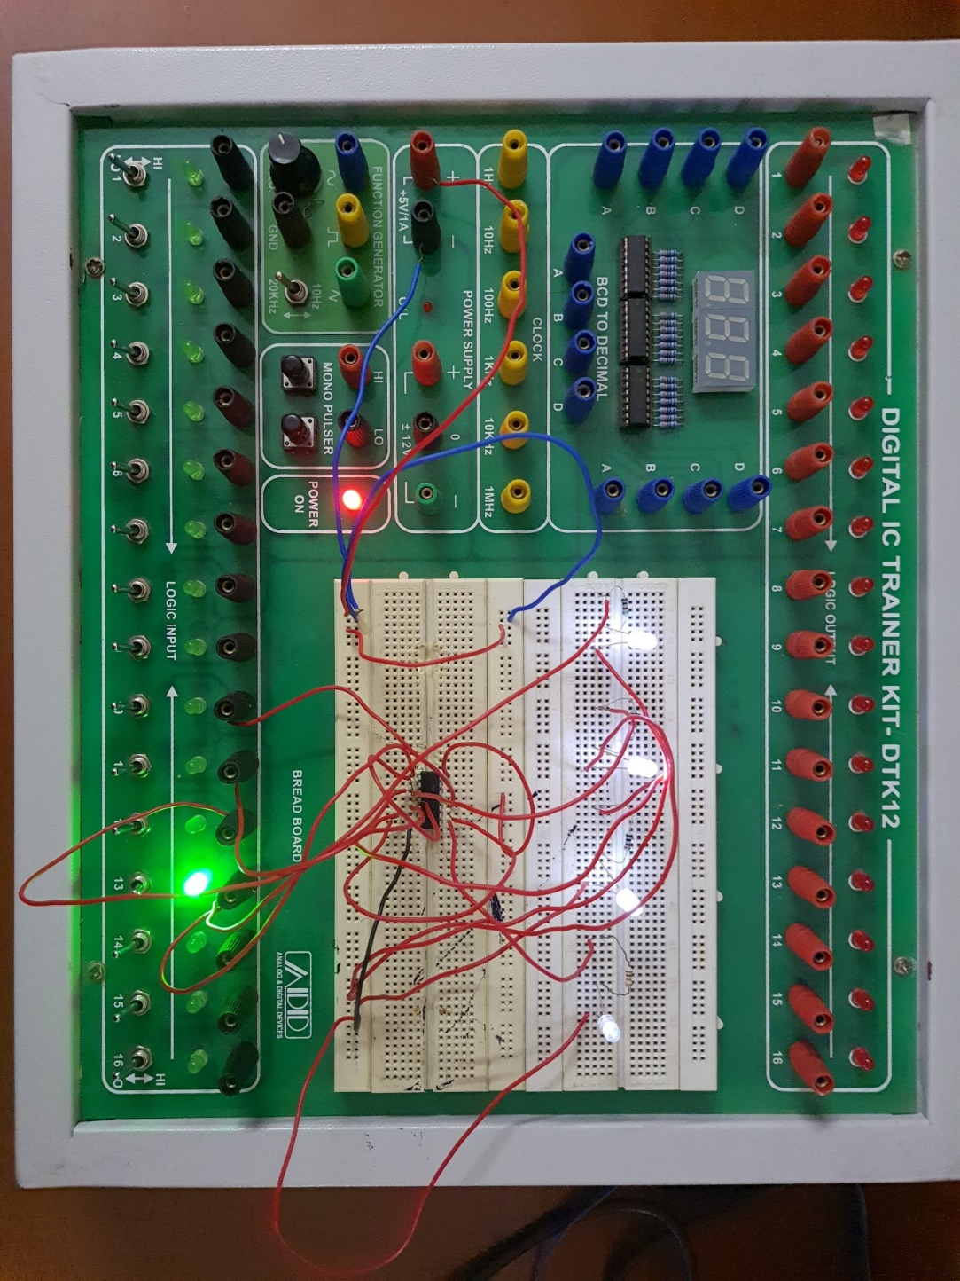

1. PCB Designing in EasyEda:

Circuit:

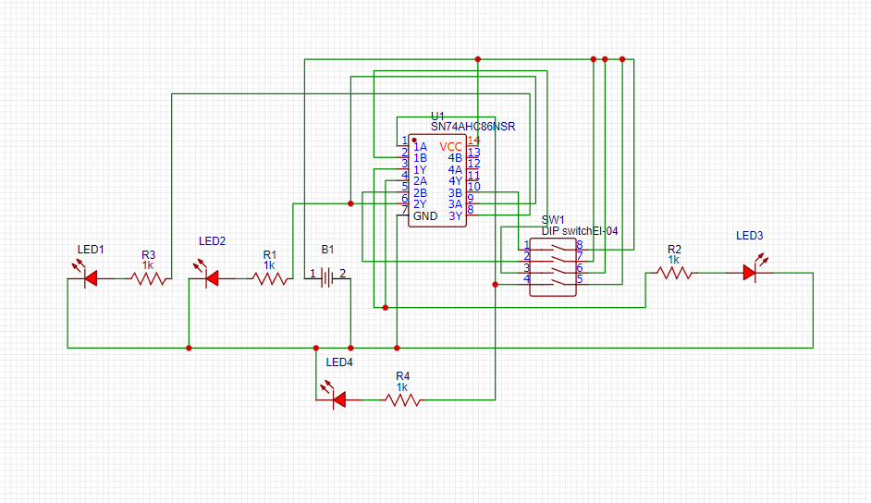

2D VIEW:

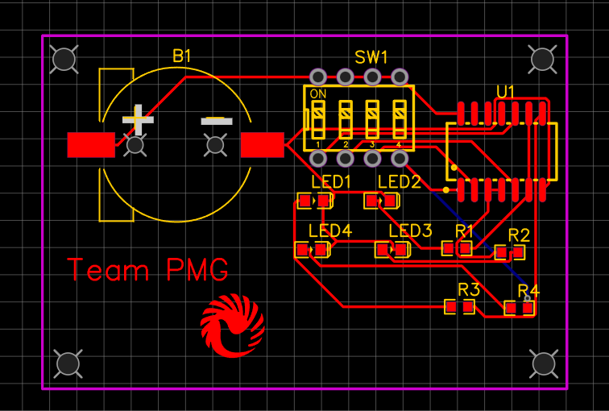

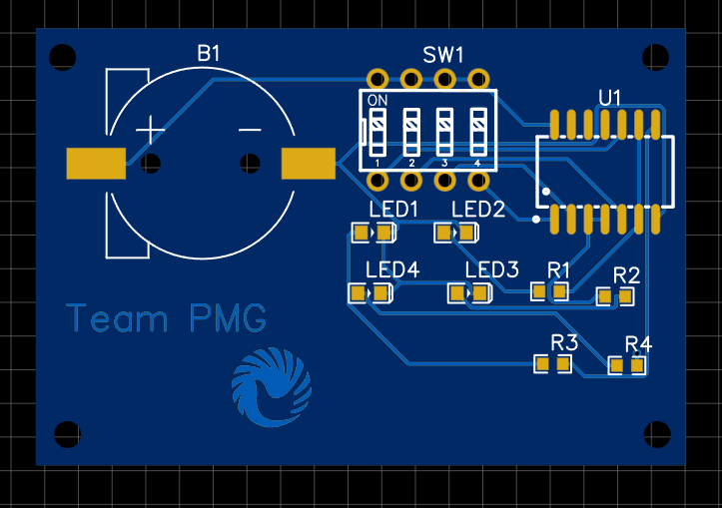

3D VIEW:

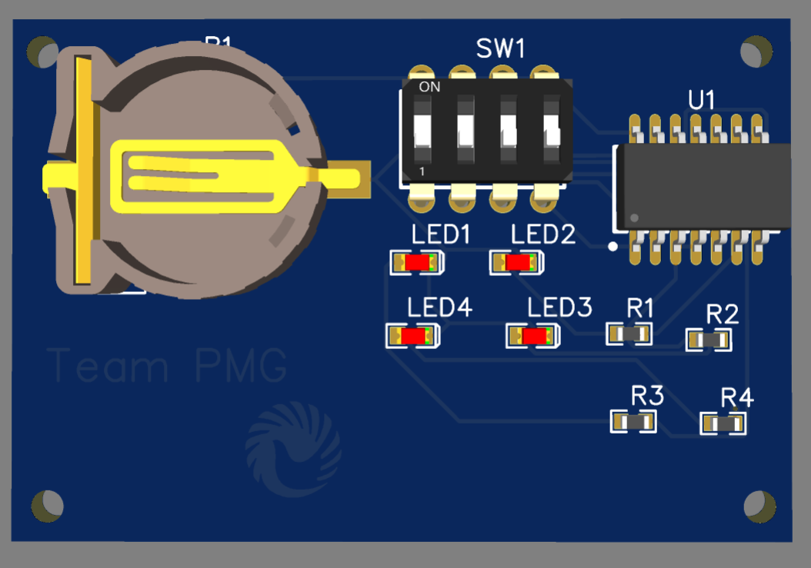

* Task-2:Analog:NPN and PNP as a SWITCH:

1. Description :

* This Tinkercad circuit showcases a dual-switch configuration employing NPN and PNP transistors (BJTs) alongside complementary components. The NPN transistor (T1) and PNP transistor (T2) act as switches, regulating the flow of current through the circuit. When slide switch S1 is activated, current passes through the base-emitter junction of T1, causing it to conduct. Consequently, current flows from the positive terminal of BAT1 through T1's collector-emitter junction, illuminating LED D1. Conversely, activating slide switch S2 enables current to flow through the base-emitter junction of T2, allowing it to conduct. This permits current to flow from the positive terminal of BAT2 through LED D2, illuminating it. The inclusion of resistors R1-R4 limits current, safeguarding the LEDs from excess. This setup demonstrates the individual control of LEDs D1 and D2 through independent activation of transistors T1 and T2, illustrating the versatile switching capabilities of both NPN and PNP transistors.

1. OUTPUTS:

Tinkercad Circuit:

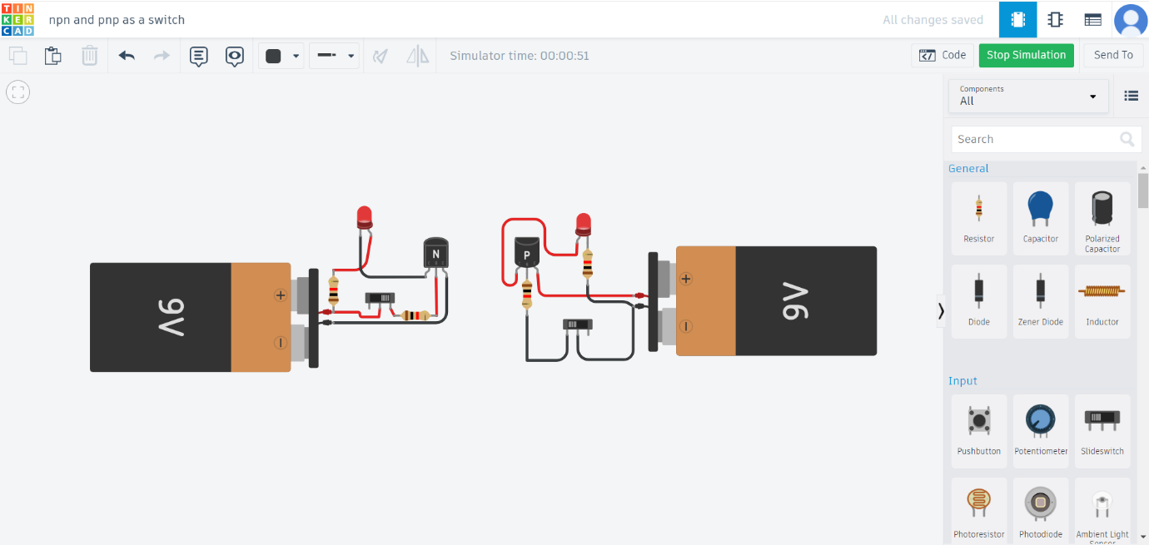

Schematic view:

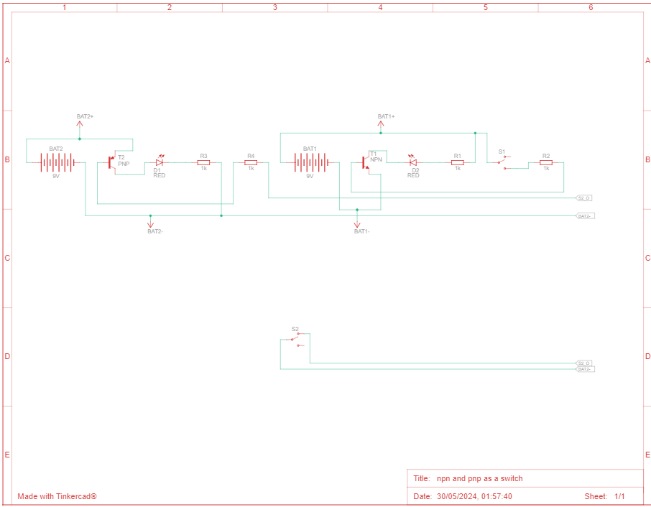

Components:

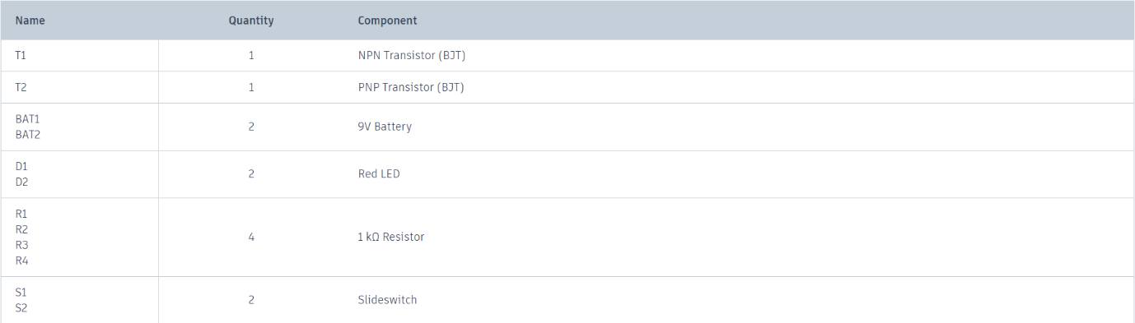

1. Transient Response:

* The transient response of a circuit, such as the one featuring NPN and PNP transistors alongside LEDs and resistors, encapsulates its behavior during the transition between steady states triggered by changes in input conditions. In this specific setup, toggling the slide switches initiates these transitions. As the switches are flipped, the circuit adjusts from one stable condition to another, with the transistors shifting from cutoff to saturation or vice versa. This transition period, known as the transient response, is characterized by the transistors' adjustment to the new signal states, causing the LEDs to either illuminate or extinguish accordingly. Factors influencing the transient response include the time constants determined by the circuit's components and the intrinsic characteristics of the transistors and LEDs. While the circuit's simplicity suggests a rapid response, further analysis through simulation or calculations could provide insights into the specific dynamics of these transitions, shedding light on the circuit's stability and responsiveness during transient states.

1. Hardware Implementation:







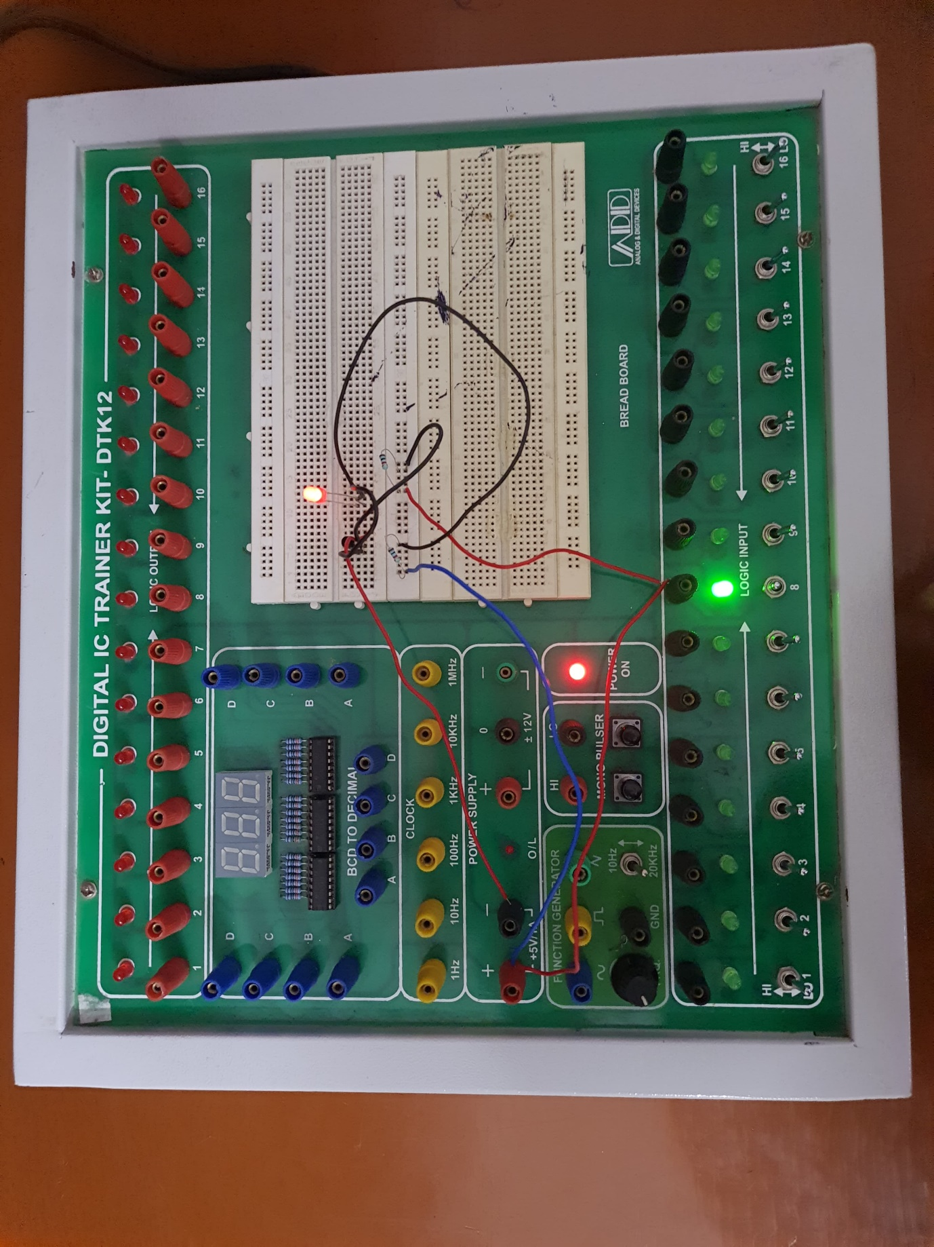

1. PCB Designing in EasyEda:

Circuit:

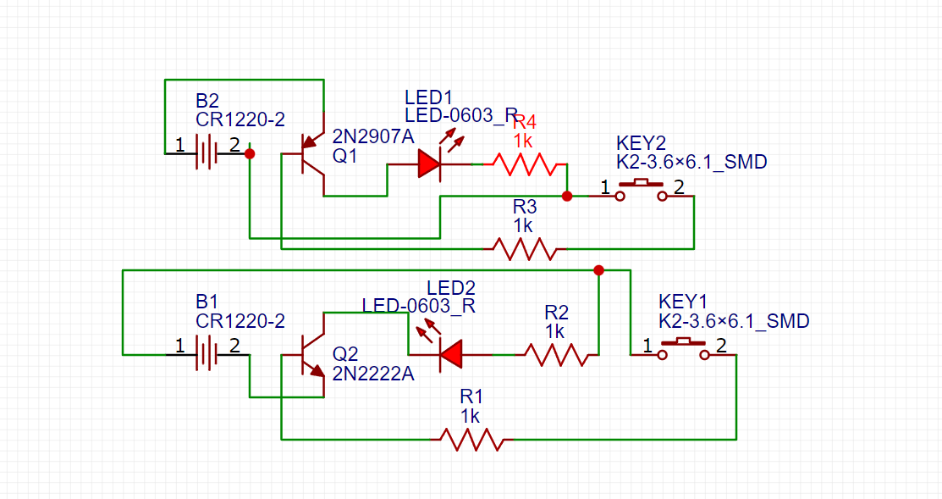

2D VIEW:

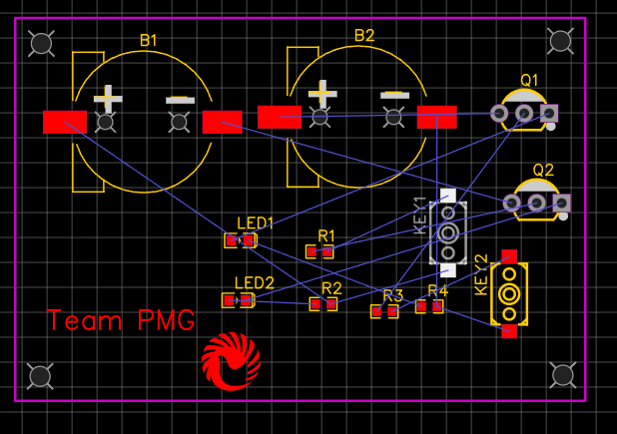

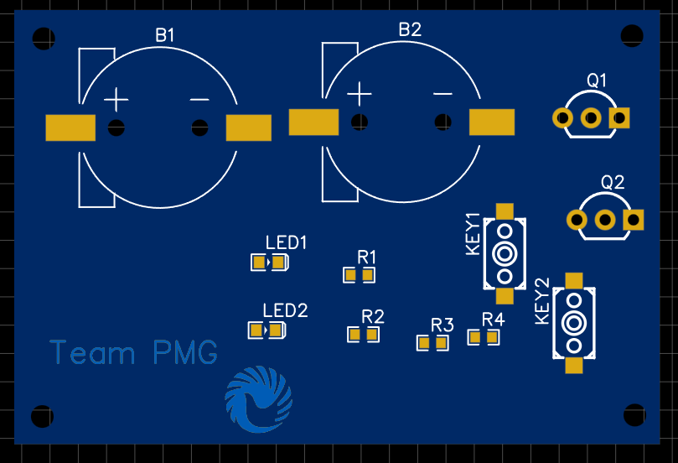

3D VIEW:

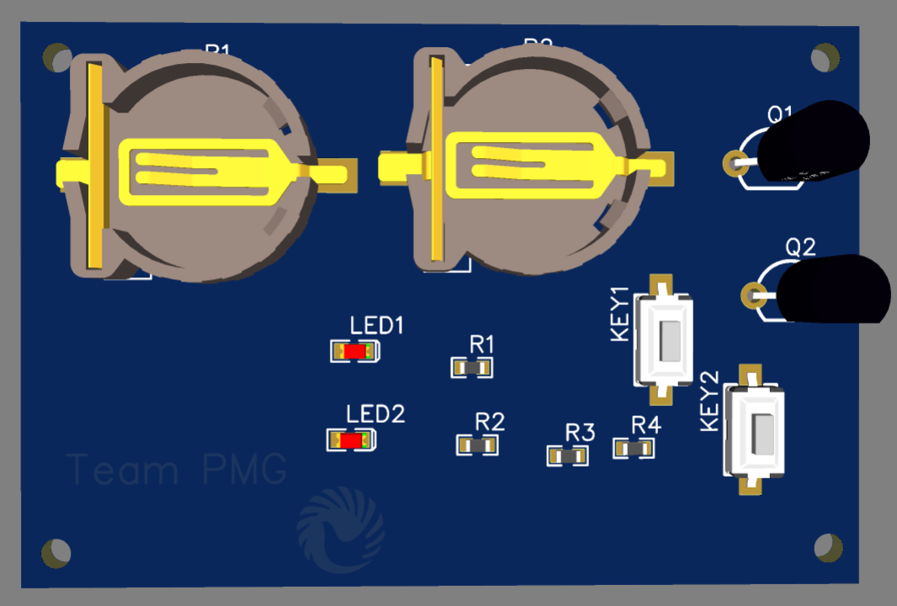

* Comparison of Simulation and Hardware Results:

In comparing the simulation and hardware results for Task 1, focusing on the gray to binary circuit, the ease of implementation in Tinkercad stands out prominently. In the simulation environment, all necessary components are readily available, facilitating seamless execution. Conversely, in the hardware implementation, our team encountered challenges sourcing the dip 4 switch, necessitating the utilization of the trainer kit logic input as an alternative. Furthermore, the use of a breadboard for connections posed additional complexity compared to the virtual environment. While initially grappling with loose connections affecting result accuracy, adjustments were made to ensure proper linkage. Notably, leveraging the inbuilt source voltage proved advantageous. Task 2, involving the use of NPN and PNP transistors as switches, similarly showcased the disparity between simulation and hardware implementation. Tinkercad's simplicity stemmed from the absence of a breadboard, allowing straightforward execution. Conversely, hardware implementation demanded meticulous attention to connection details, compounded by the challenge of sourcing specific components like NPN and PNP transistors. The arduous task of locating these components within EasyEDA tools added to the complexity. In summary, while simulation environments offer convenience and accessibility, hardware implementation necessitates meticulous attention to detail and component availability, underscoring the importance of adapting strategies accordingly

* Download the Gerber File:

To download the Gerber file of the final PCB design from EasyEDA, log in to your account and open the project containing the PCB design. Ensure the design is error-free, then navigate to the PCB Editor. From the "Manufacture" menu, select "Fabrication Output" and choose the Gerber format (RS-274X or Extended Gerber). Export the Gerber files, then download the ZIP file containing them. To submit the Gerber files to a PCB fabrication service, select a service like JLCPCB or PCBWay and upload the Gerber files. Specify PCB specifications such as material, thickness, and surface finish, review the order details, and place the order. Monitor the order status for updates. These steps simplify downloading the Gerber file from EasyEDA and submitting it for PCB fabrication.

* Appendix

• **Explore Circuit Design:**

Uncover the intricacies of circuit design with an overview of wiring boards, breadboards, strip boards, traditional PCBs, and PCBs with solder masks.

• **Get Hands-On: Advantages and Disadvantages:**

Engage in an insightful activity listing out the advantages and disadvantages of breadboards, a fundamental tool in prototyping circuits.

• **Watch and Learn: Video Resources:**

Immerse yourself in the world of PCBs through engaging video content covering their importance, manufacturing processes, and applications.

• **Spot the PCB: Items in Your Classroom:**

Discover the ubiquity of PCBs by identifying items in your surroundings that contain them, adding a tangible dimension to your learning experience.

• **Unlock Career Opportunities:**

Delve into the diverse career prospects and industries associated with PCB designing, including insights into India's thriving PCB market.

• **Poll Results: Global Perspectives:**

Gain insights into the global landscape of PCB manufacturing through the results of a thought-provoking poll question.

• **Workshop Journey: Step-by-Step Guide:**

Navigate through the workshop's flow, from simulation to hardware design and PCB creation, with a detailed roadmap of each stage.

• **Craft Your PCB: Etching Technique Unveiled:**

Master the art of PCB design using the etching technique, equipped with a comprehensive list of materials and step-by-step instructions.

• **Circuit Catalog: Analog, Digital, and Mixed Signals:**

Browse through a curated list of circuits, spanning basic to advanced levels, categorized by type for easy reference and exploration.

• **Design Challenges Await: Contest Highlights:**

Elevate your skills by participating in PCB design contests, each with a unique theme and exciting opportunities for innovation.

• **Inspiration Awaits: Sample Circuits:**

Spark your creativity with examples of circuits, including LED blinking, Half-Adder, and Inverting Amplifier, ready to ignite your imagination.

• **Expand Your Horizon: External Resources:**

<https://www.youtube.com/watch?v=o8NOK1JJbgw>

<https://oshwlab.com/>

<https://www.instructables.com/Practical-Circuit-Construction-With-Strip-Board/>

<https://www.youtube.com/watch?v=GHtCEed583w>

<https://www.youtube.com/watch?v=IRJ6YL_R8a8>

<https://www.youtube.com/watch?v=IRJ6YL_R8a8>

<https://www.youtube.com/watch?v=IRJ6YL_R8a8>

<https://www.youtube.com/watch?v=IRJ6YL_R8a8>